|  |  |  |
| --- | --- | --- |
| **Problem Chosen** B | **2026 MCM/ICM Summary Sheet** | **Team Control Number** 2616826 |

**Summary**

Facing the logistics challenge of delivering 100 million tonnes of construction materials to the Moon for colony construction, this paper establishes an Earth–Moon logistics evaluation framework to seek an optimal balance among construction duration, fiscal budget, failure risk, and environmental cost within a complex multi-path transport network. Through quantitative analysis of the space elevator and conventional rockets, we provide actionable implementation strategies.

For Problem 1, we develop a time–cost trade-off model for Earth–Moon transportation. We introduce a latitude correction factor to differentiate the effective payload across launch sites, and convert the annual throughput of the spaceport and the launch frequency of the space base into inequality constraints to define the physically feasible region; a scale-discount factor is coupled to capture marginal cost reduction under large-scale industrialization. We construct the Pareto frontier and, based on the diminishing-returns knee point, select a hybrid scheme with a duration of 150 years and a cost of USD 192.9 trillion, in which rockets deliver about 61.95 million tonnes and the elevator delivers about 38.05 million tonnes. Subject to all physical bottlenecks, this scheme achieves the best balance between engineering timeliness and fiscal intensity.

For Problem 2, we develop a reliability and risk assessment framework integrating multi-source stochastic disturbances. We use Monte Carlo simulation to quantify capacity loss from space-elevator tether oscillations and construct a Pareto-frontier band. We model rocket-explosion compensation and launch sunk costs as stochastic economic shocks, and build a discrete-event simulation incorporating heterogeneous base failure queues and irrecoverable window losses. We further embed cross-system dynamic backfilling to trigger emergency ground-rocket response during elevator downtime. Results indicate high structural stability of the Earth–Moon transport balance model: under the same marginal investment willingness, the optimal time shift is −4.1% to +1.9%, and the risk premium is bounded within 0.3% to 3.6%.

For Problem 3, we propose a dynamic programming model with assembly constraints and survival-threshold limits. Threshold conditions are embedded in the Bellman equation, so transfer rockets can launch only after the apex-anchor inventory reaches full load (or when the survival threshold is triggered). A stepwise penalty term is added to discourage stockouts. The optimal policy deploys ground rockets in the first three days to build safety stock (96% of total cost), then enters a steady-state cycle in which nine full-load transfer launches meet annual demand. With a total budget of USD 506.7 billion, the plan secures an annual water supply of 34,000 tonnes..

For Problem 4, we develop a multidimensional environmental-economics framework that makes three hidden costs explicit: atmospheric impacts, resource depletion, and indirect carbon footprint. We incorporate them into the objective function and reconstruct the Pareto frontier. Under the same marginal input–output ratio, the marginal equivalence point shifts to 208.4 years, with a total social cost of USD 178.4 trillion—about USD 14.5 trillion lower than the financially optimal scheme. Although the construction period increases by 58.4 years, the Earth–Moon logistics chain enters a more favorable “green operating region.”

Finally, we propose integrated recommendations for the MCM: use the 150-year hybrid scheme as the financially feasible baseline; reserve a 2%–5% schedule buffer for risk; prioritize advance water stockpiling to avoid cold-start costs; and, when policy emphasizes social welfare and environmental constraints, shift the target timeline toward the 208.4-year green optimum.

**Keywords: Pareto optimization; Monte Carlo simulation; dynamic programming.**

Contents

**1 Introduction 4**

1.1 Problem Background 5

1.2 Restatement of the Problem 5

**2 Assumptions and Justifications 4**

**3 Notations 4**

**4 Model 1： 4**

4.1 Data Collection and Processing 5

4.2 5

4.3.1 5

4.3.2 5

4.5 Summary 5

**1. Introduction**

**1.1 Problem Background**

In the future, anyone could reach Earth orbit via a leisurely and scenic journey from the equator, and then take routine, safe, and low-cost rocket flights to the Moon, Mars, or beyond.

The Lunar Colony Administration is preparing to build a lunar colony with an expected population of 100,000, with construction planned to start in 2050; prior to this, the space-elevator system must be completed. Each Galaxy Port will include an Earth port and multiple space elevators, lifting massive cargo from Earth to geostationary Earth orbit (GEO) and further to the apex anchor, where the cargo can be loaded onto rockets and transported anywhere with less fuel.

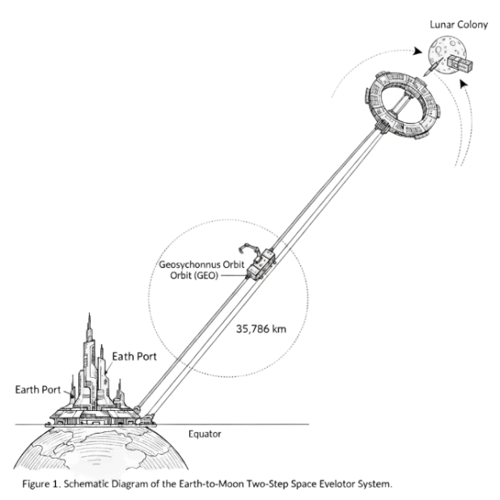

*Figure 1-1. Concept rendering of the space elevator*

**1.2 Restatement of the Problem**

Based on the background information and constraints specified in the problem statement, we address the following tasks:

Problem 1: Evaluate the cost, timeline, and feasibility of three transportation strategies:

$$\left\{\begin{aligned}Option A: Use only the space-elevator system, consisting of three equatorial Galaxy Ports. \\ Option B: Use only conventional rockets launched from ten global launch sites. \\ Option C: Use a hybrid strategy combining the two systems. \end{aligned}\right.$$

The space elevator has very low unit energy cost but a strict annual throughput cap; reusable heavy-lift rockets offer high flexibility and throughput potential but require substantial propellant. We aim to build a mathematical model that balances the massive demand against a tight schedule to determine the optimal logistics strategy.

Problem 2:Large-scale engineering projects inevitably face physical disturbances and system failures. This task relaxes ideal assumptions and evaluates how solutions deviate under non-ideal operating conditions, focusing on sensitivity to environmental disturbances, infrastructure fragility, the cost of catastrophic failures, and cross-system risk hedging.

Problem 3:After the 100,000-person lunar colony is completed and operational, the mission focus shifts from transporting structural materials to ensuring life-support supplies. This task estimates and quantifies the total annual water demand at full capacity, and, using the previously developed transport model, proposes a water-transport plan that ensures one-year sufficiency while accounting for economic and time costs.

Problem 4:Sending 100 million tons of materials into space is an unprecedented industrial activity with non-negligible potential impacts on Earth’s ecosystem. This task shifts the perspective from “within the project” to “outside the planet,” examines multidimensional environmental impacts, compares the environmental performance of the space elevator and conventional rockets, and adjusts the prior optimal decision by introducing environmental social costs to minimize the overall footprint.

Problem 5:After analyzing physical limits, risk resilience, life-support provisioning, and life-cycle environmental social costs of the Earth–Moon logistics chain, we translate the mathematical results into administratively actionable strategic recommendations and submit a policy letter to the lunar colony authority.

**1.3 Our Work**

According to the above requirements, our workflow is summarized in the figure below.

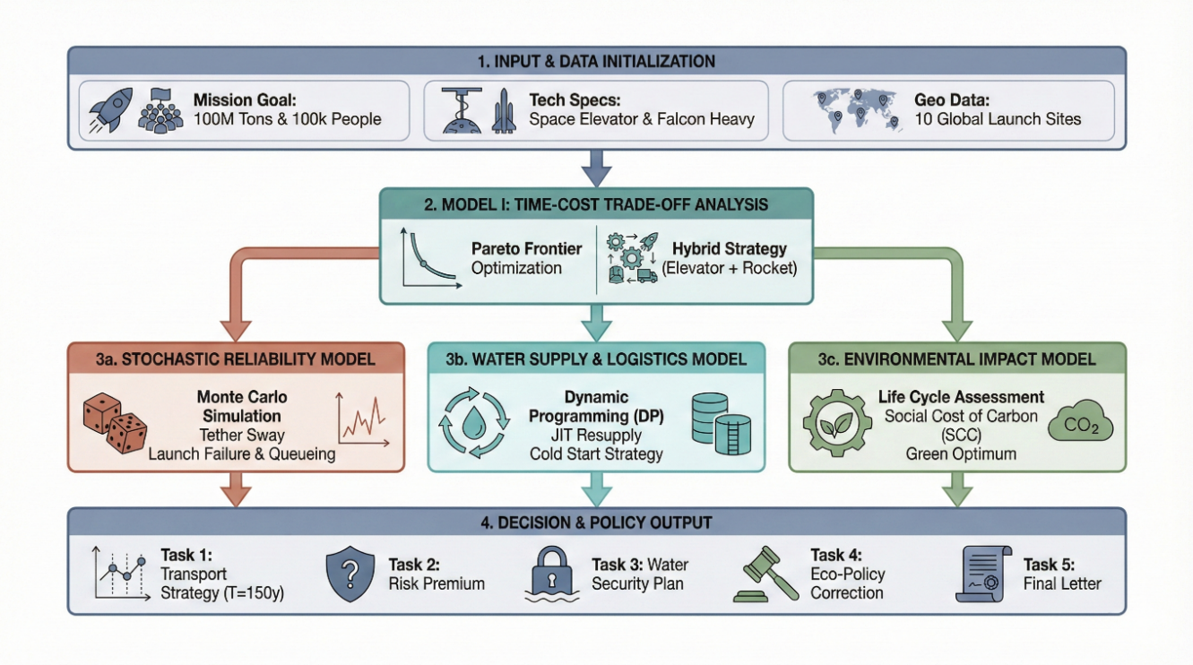

*图1-2. Our Work*

**2. Assumptions and Justifications**

To simplify the model and highlight the core logic, we make the following assumptions:

Assumption 1 (Technological continuity over the project lifecycle):After construction begins in 2050, the key technical parameters of the space elevator and advanced heavy-lift rockets remain dynamically stable throughout the construction period, with no disruptive regressions or breakthroughs.

Rationale 1:This provides a baseline for long-term forecasting and allows us to focus on the structured combination of transport modes rather than stochastic fluctuations in technical details.

Assumption 2 (Neglect initial construction losses on the Moon):The 100 million metric tons delivered to the Moon are assumed to be converted into effective building structures with 100% efficiency.

Rationale 2:The problem provides no material conversion-rate parameter, and treating it as a constant does not affect the cross-scheme comparison among the three transport strategies.

Additional model-specific premises are stated explicitly within each model.。

**3. Notations**

The main mathematical symbols used in this paper and their definitions are listed in Table 3-1.

**Table 3-1. Notations**

|  |  |  |  |  |
| --- | --- | --- | --- | --- |
| **Symbol** | | **Description** | **Unit** | |
| $$M$$ | Net mass of construction materials | | | $$t$$ |
| $$T$$ | Construction duration | | | $$year$$ |
| $$γ$$ | Elevator tether oscillation factor | | | $$dimensionless$$ |
| $$C$$ | Total lifecycle project cost | | | $$Trillion USD$$ |
| $$U$$ | Nominal annual capacity of a single Galaxy Port | | | $$t/year$$ |
| $$W$$ | Total annual water demand for full-capacity colony operation | | | $$t/year$$ |
| $$η_{E}$$ | Energy conversion efficiency of the space elevator | | | $$\%$$ |
| $$R$$ | Lunar-mission payload of a single advanced rocket | | | $$t/launch$$ |

Local variables used in each model are defined when they first appear.

**4. Model 1：Time–cost trade-off model for Earth–Moon transportation.**

To quantify the trade-off between the space elevator and conventional rockets, we develop a time–cost trade-off model for Earth–Moon transportation. The model uses physics-based cost accounting to ensure technical feasibility

This problem transports 100 million metric tons of construction materials to the lunar colony:

Method 1:Space elevator only—lift cargo to the apex anchor, then use transfer rockets to deliver it to the Moon.

Method 2:Ground launch bases only—use conventional rockets to deliver cargo directly from Earth to the Moon.

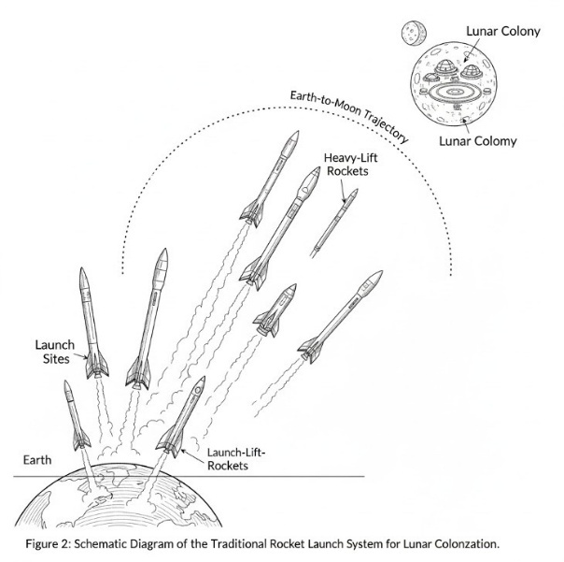

*Figure 1-3. Schematic of conventional rocket transportation.*

Method 3:A hybrid strategy combining Methods 1 and 2, with the space elevator and rockets operating in parallel.

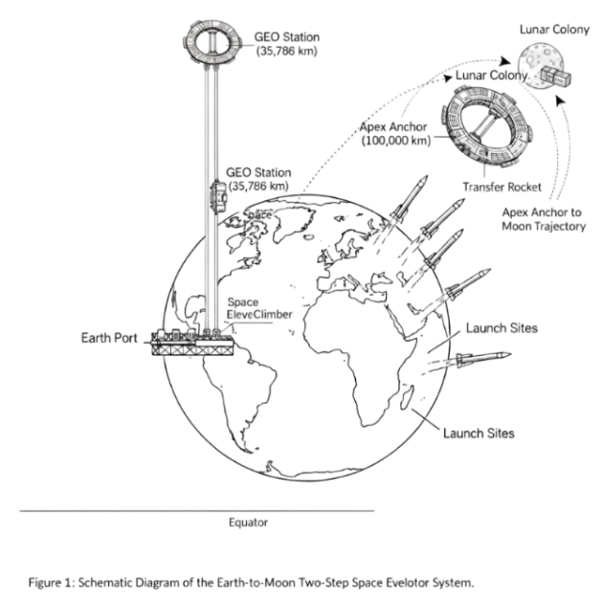

*图1-4. Schematic of parallel transportation using the space elevator and conventional rockets.*

Considering differences in efficiency, fuel consumption, and capacity between the elevator and rockets, we build an optimization model to compare the transportation time and cost of the three schemes and identify the optimal strategy.

**4.1. Decision variables.**

Net mass of construction materials delivered to the Moon via Method 1 (elevator + transfer rockets) through the $i$ Galaxy Port:：

$$m_{i}≥0, i=1,2,3$$

Net mass of construction materials delivered to the Moon via Method 2 (direct ground-launched rockets) through the $j$ launch base:

$$n_{j}≥0, j∈J, \left|J\right|=10$$

Total mission constraint.

$$\begin{aligned}\sum_{i=1}^{3}{m_{i}}+\sum_{j∈J}{n_{j}}=M\#\left(1\right)\end{aligned}$$

**4.2 Rocket equation and fuel mass fraction calculation.**

For any rocket leg from a given origin to the Moon, let the required velocity increment be $Δv$, the specific impulse be $I_{sp}$, and the standard gravitational acceleration be $g_{0}$. We then define the structural coefficient (the ratio of dry mass to payload) as:

$$\begin{aligned}α=\frac{m_{\text{dry}}}{m_{\text{payload}}}\#\left(2\right)\end{aligned}$$

The mass ratio is given by the rocket equation:

$$\begin{aligned}R\left(Δv\right)=\exp\left(\frac{Δv}{I_{sp}g_{0}}\right)\#\left(3\right)\end{aligned}$$

Let the payload be $m_{\text{payload}}$ ; then the final mass (after propellant depletion) is:

$$\begin{aligned}m_{f}=m_{\text{payload}}+m_{\text{dry}}=\left(1+α\right)m_{\text{payload}}\#\left(4\right)\end{aligned}$$

The initial mass (total mass before ignition) is:

$$\begin{aligned}m_{0}=R\left(Δv\right)⋅m_{f}=R\left(Δv\right)\left(1+α\right)m_{\text{payload}}\#\left(5\right)\end{aligned}$$

The propellant mass is then:

$$\begin{aligned}m_{\text{prop}}=m_{0}-m_{f}=\left(R\left(Δv\right)-1\right)\left(1+α\right)m_{\text{payload}}\#\left(6\right)\end{aligned}$$

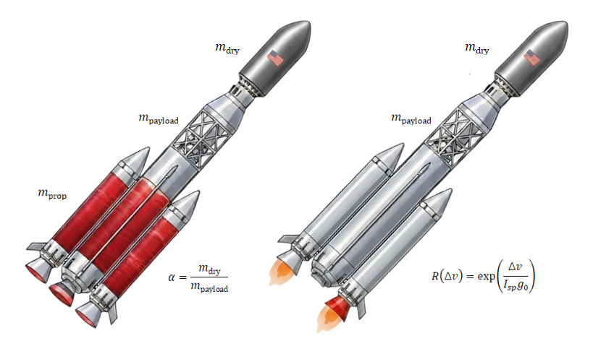

*Figure 4-1. Schematic of rocket mass and payload*

**4.3 方案A成本**

For transfer rockets from the apex anchor to the lunar colony, let the required velocity increment be $Δv_{A}=2.2 \text{km}\text{/}\text{s}$, the specific impulse be $I_{sp,A}=450 \text{s}$, and the structural coefficient (dry mass / net material mass) be $α_{A}$. Then, the total initial mass required to deliver 1 tonne of materials $m_{i}$ is:

$$\begin{aligned}m_{0,A}\left(m_{i}\right)=\underset{κ_{A}}{\underbrace{R_{A}\left(1+α_{A}\right)}}⋅m_{i}\#\left(7\right)\end{aligned}$$

where

$$\begin{aligned}κ_{A}=R_{A}\left(1+α_{A}\right),R_{A}=\exp\left(\frac{Δv_{A}}{I_{sp,A}g_{0}}\right)\#\left(8\right)\end{aligned}$$

$κ_{A}$ is the “mass amplification factor” by which the two-stage transfer rocket and its propellant occupy elevator capacity; thus, the elevator must lift $κ_{A}m_{i}$, and the propellant mass is :

$$\begin{aligned}m_{\text{prop},A}\left(m_{i}\right)=\left(R_{A}-1\right)\left(1+α_{A}\right)m_{i}\#\left(9\right)\end{aligned}$$

Since departure from geostationary orbit occurs in vacuum with no aerodynamic drag, the rocket structure can be very lightweight. Ignition in orbit also allows slow acceleration using low-thrust, high-efficiency engines; therefore, we set $α_{A}=0.3$.

The problem specifies an annual throughput cap of $U=179000$ for each Galaxy Port. The total mass that the elevator can lift each year should satisfy : $κ_{G}m_{i}≤UT, i=1,2,3$。

Therefore, the net material throughput (per port) achievable within time [[EQ1]] is $UT/κ_{G}$

The total cost of this scheme includes the elevator electricity cost and the transfer-rocket cost.

(1) Elevator electricity cost

The energy required to lift 1 kg from Earth’s surface to the apex anchor is computed using the gravitational potential energy difference:

$$\begin{aligned}Δε=μ\left(\frac{1}{R_{E}}-\frac{1}{r_{\text{A}}}\right) \left(\text{J}\text{/}\text{kg}\right)\#\left(10\right)\end{aligned}$$

where the Earth radius is $R_{E} = 6378km$, the apex-anchor altitude is $r_{\text{A}} =100000km$, and the Earth gravitational parameter is:

$$\begin{aligned}μ=GM≈398,600.44 \frac{{\text{km}}^{3}}{{\text{s}}^{2}}\#\left(11\right)\end{aligned}$$

Given an overall elevator efficiency $η_{E}$  and an electricity price $π_{E}$  (CNY/kWh), the electricity cost to lift a mass $m$ (tonnes) is :

$$\begin{aligned}C_{\text{elec}}\left(m\right)=\frac{\left(1000m\right)Δε}{η_{E}⋅3.6×{10}^{6}}π_{E}\#\left(12\right)\end{aligned}$$

For port $i$  the lifted mass is $κ_{A}m_{i}$ , so $C_{\text{elec},i}=C_{\text{elec}}\left(κ_{A}m_{i}\right)$. In the electricity-pricing formula, $η_{E}$ consists of three components.：

$$\begin{aligned}η_{E}=η_{\text{transmission}}×η_{\text{conversion}}×η_{\text{mechanical}}\#\left(13\right)\end{aligned}$$

$η_{transmission}$ denotes the transmission efficiency of power from the ground to the climber (90%); $η_{\text{conversion}}$ denotes the conversion efficiency from received energy to electrical power (95%); and $η_{\text{mechanical}}$ denotes the mechanical efficiency of the wheels in overcoming friction (95%).

The electricity price is $π_{E} = 0.03 USD/kWh$.

(2) Transfer-rocket cost

Let the unit cost of transfer-rocket dry mass be $c_{\text{dry},A}$ ​ (CNY/tonne) and the unit cost of propellant be $c_{\text{prop},A}$ (CNY/tonne). The dry mass is $α_{A}m_{i}$ and the propellant mass is $\left(R_{A}-1\right)\left(1+α_{A}\right)m_{i}$:

$$\begin{aligned}C_{\text{rocket},A,i}=c_{\text{dry},A}⋅α_{A}m_{i}+c_{\text{prop},A}⋅\left(R_{A}-1\right)\left(1+α_{A}\right)m_{i}\#\left(14\right)\end{aligned}$$

Thus, the total cost of Method 1 is:

$$\begin{aligned}C^{\left(1\right)}=\sum_{i=1}^{3}{\left(C_{\text{elec}}\left(κ_{A}m_{i}\right)+C_{\text{rocket},A,i}\right)}\#\left(15\right)\end{aligned}$$

$c_{\text{dry},A}≈3.1×{10}^{6} \text{USD}\text{/}\text{t}$, $c_{\text{prop},A}≈5.0×{10}^{2} \text{USD}\text{/}\text{t}$.

**4.4. Cost of Method 2.**

Let the latitude of launch base $j$ be $φ_{j}$. The Earth’s rotational linear speed at the equator is $ωR_{E } = 465.1m/s$; the prograde velocity gain at latitude $φ_{j}$ is:

$$\begin{aligned}v_{\text{rot}}\left(j\right)=ωR_{E}\cos{φ_{j}}\#\left(16\right)\end{aligned}$$

We then compute the required velocity increment for the launch base as：

$$\begin{aligned}Δv_{j}=Δv_{\text{base}}-v_{\text{rot}}\left(j\right)\#\left(17\right)\end{aligned}$$

where the required velocity increment from the ground to the Moon is $Δv_{\text{base}} = 15.2 km/s$. The mass ratio is $R_{j}=\exp\left(\frac{Δv_{j}}{I_{sp,E}g_{0}}\right)$, where $I_{sp,E} = 480s$. Then the required propellant mass and dry mass for each launch can be computed.

Each base has a daily launch-cap limit of $λ_{j}=2$ and the maximum pre-ignition mass of the rocket is $L_{E}$  (tonnes per launch). The maximum annual construction-material delivery of each base is：

$$\begin{aligned}n_{j}≤λ_{j}T⋅\frac{L_{E}}{R_{j}\left(1+α_{E}\right)}, j∈J\#\left(18\right)\end{aligned}$$

Because ground-launched rockets must pass through the dense atmosphere in a short time and withstand large dynamic pressure and aerodynamic heating, the shell and structural frame must be very robust and thus heavy. Therefore, we set $α_{E} = 0.6$.。

Therefore, the rocket cost for each base is:

$$\begin{aligned}C^{\left(2\right)}=\sum_{j∈J}{\left(c_{\text{dry},E}⋅α_{E}n_{j}+c_{\text{prop},E}⋅\left(R_{j}-1\right)\left(1+α_{E}\right)n_{j}\right)}\#\left(19\right)\end{aligned}$$

Rockets are industrial products, and under Wright’s law, mass production of tens of thousands of rockets to transport tens of millions of tonnes yields economies of scale. We therefore introduce a scale factor $γ= 0.2$ and adjust the rocket cost to:

$$\begin{aligned}C^{\left(2\right)}←C^{\left(2\right)}×\left(1-γ×\frac{{\text{Mass}}_{\text{Rocket}}}{M_{\text{Total}}}\right)\#\left(20\right)\end{aligned}$$

**4.5. Cost of Method 3.**

The elevator and rockets operate in parallel, with total delivered construction material $M$, subject to the following parallel constraints:

$$\begin{aligned}κ_{G}m_{i}≤UT, i=1,2,3\#\left(21\right)\end{aligned}$$

$$\begin{aligned}n_{j}≤λ_{j}T⋅\frac{L_{E}}{R_{j}\left(1+α_{E}\right)}, j∈J\#\left(22\right)\end{aligned}$$

the cost of the hybrid method is the sum of the elevator transport cost and the rocket transport cost:

$$\begin{aligned}C^{\left(3\right)}=C^{\left(1\right)}+C^{\left(2\right)}\#\left(23\right)\end{aligned}$$

**4.6. Objective function and model solution.**

To account for the time constraint, we introduce a schedule-pressure penalty term:

$$\begin{aligned}pressure=\frac{T_{\text{MAX}}-T}{T_{\text{MAX}}-T_{\text{MIN}}}\#\left(24\right)\end{aligned}$$

The objective function is:

$$\begin{aligned}\min{J}=C^{\left(3\right)}⋅\left(1+δ⋅\left(pressure^{2}\right)\right)\#\left(25\right)\end{aligned}$$

All constraints above are enforced, with pressure coefficient $δ=0.5$. For Method 1, we enforce ${ n}_{j}=0$; for Method 2, we enforce $m_{j}=0$ ; for Method 3, both operate in parallel.

We construct a dynamic resource-allocation solver to fit the Pareto frontier. Using a sweep approach, it searches for the minimum-cost point within the physical schedule limit. Fixed-point iteration is used to capture the scale effect of rocket launches, ensuring that resource allocation at each time point follows the marginal-cost optimum. By adding the schedule-pressure penalty function, we quantify the marginal economic loss of extreme schedule compression, yielding a Pareto frontier that reflects realistic engineering decision boundaries, as shown in Fig. 4-2.

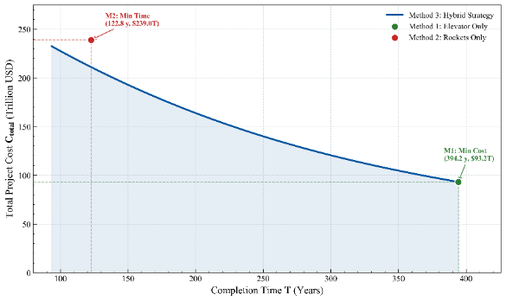

*Figure 4-2. Pareto frontier of the time–cost trade-off model.*

The figure shows the trade-off between completion time and total project cost. The curve is convex and extends toward the upper left, indicating a strict negative correlation between time and cost.

Scheme A (all elevator, green dot):As the “baseline cost floor” (USD 93 trillion, 394 years), it has the lowest cost but an extremely long duration. In the relatively flat region on the right, introducing a small number of rockets can substantially shorten the schedule at low marginal cost.

Scheme B (all rockets, red dot):It represents the “physical minimum time” (USD 239 trillion, 122 years). The curve is steep on the left, indicating that when the schedule is compressed to within 150 years, marginal cost rises sharply as launch frequency increases.

Scheme C (hybrid strategy, blue line):The Pareto frontier demonstrates a synergy effect: the elevator carries the base load, while rockets fill the gap. Under the same schedule constraint, the hybrid scheme is always less costly than either single-mode scheme. The table below summarizes several key points on the Pareto curve and lists their values, showing how the internal resource allocation evolves as the required schedule shortens.

Table 4-2. Detailed Resource Allocation across Pareto Points

|  |  |  |  |  |  |
| --- | --- | --- | --- | --- | --- |
| **Scenario** | **Time** | **Cost（T）** | **Elevator Mass** | **Kourou (GUF)** | **…** |
| Method 1 | 394.2 | 93.1 | 100000000 | 0 | … |
| Method 2 | 122.7 | 238.9 | 0 | 10201358.9 | … |
| Method 3 (Point 0) | 93.6 | 232.4 | 23743846.3 | 7779163.98 | … |
| Method 3 (Point 33) | 193.8 | 167.1 | 49162564.2 | 16107063.8 | … |
| Method 3 (Point 66) | 294.0 | 122.6 | 74581282.1 | 24434963.6 | … |
| … | … | … | … | … | … |

Based on the trade-off analysis, we select [[EQ1]] as the final recommended plan. Table 2 compares this plan with the two extreme schemes.

Table 4-3. Scenario Comparison at the Selected 150-Year Timeline

|  |  |  |  |  |
| --- | --- | --- | --- | --- |
| **Method** | **Time** | **Cost (T)** | **Rocket Mass** | **Elevator Mass** |
| Method 1 (Elevator) | 394.2 | 93.1 | 0 | 100000000 |
| Method 2 (Rocket) | 122.7 | 238.9 | 100000000 | 0 |
| Method 3 (Hybrid @150year) | 150 | 192.9 | 61952952.6 | 38047047.3 |

Selecting 150 years is a strategic decision based on the cost–performance knee point. Compared with M1, we increase the budget by only about twofold while reducing the duration by 62%, bringing completion within a foreseeable horizon of human civilization. Compared with M2, we extend the duration by about 27 years, yet this modest concession saves humanity USD 46 trillion in total expenditure.

**5. Model 2：Stochastic Reliability and Risk Assessment Framework**

In real-world conditions, the transportation system cannot operate perfectly; issues such as tether oscillations, rocket failures, and elevator damage may occur. Therefore, we extend the deterministic model in Question 1 into a stochastic reliability and risk assessment framework. Its core idea is to shift from “static optimization” to “dynamic defensive simulation.”

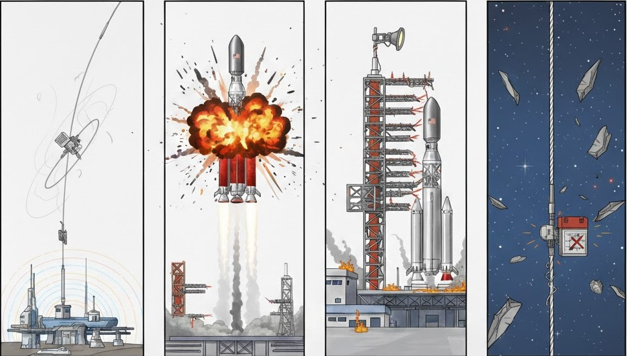

*Figure 5-1. Schematic of stochastic failures in the transportation system*

To accurately simulate random disturbances in a complex system, this framework integrates multiple mathematical tools:

**Uncertainty quantification module:** Using Monte Carlo simulation, we efficiently capture fluctuations in effective transport capacity induced by elevator oscillations within the uncertainty space, and construct a confidence-interval-based Pareto frontier band.

**Heterogeneous queueing simulation module:** Based on infrastructure echelon theory, we employ discrete-event simulation (DES) to model the stochastic failure processes of the 10 global launch bases, revealing the deep impact of inter-base disparities on system availability.

**Dynamic make-up cost integral model:** We establish a coupled cross-system response logic. When the primary space elevator is shut down for maintenance, the rocket system dynamically compensates for the resulting task shortfall, and a definite-integral model is used to precisely capture cost variations due to scale effects under risk scenarios.

With this framework, our output is no longer a single “successful” number, but a “risk white paper” with explicit confidence levels, aiming to identify the optimal strategy that remains resilient even in the face of disasters.

**5.1 Elevator Oscillation Uncertainty**

In practice, the space elevator’s effective capacity is not constant due to Coriolis effects, orbital perturbations, and oscillations. To assess robustness, we model this uncertainty with random variables.

**5.1.1 Definition of Random Variables**

We introduce an oscillation factor $Y$ to adjust the elevator’s effective throughput. $Y$ is a multiplicative factor representing capacity loss, with $Y≥1.0$.

Under oscillation uncertainty, the effective annual throughput upper bound of the $i$ Galactic Harbour is corrected from the nominal value $U$ to:

$$\begin{aligned}U_{\text{eff}}=\frac{U}{Y}\#\left(26\right)\end{aligned}$$

Assume $Y$ follows a truncated normal distribution: $Y∼N\left(μ_{Y},σ_{Y}^{2}\right), \text{subject to }Y≥1.0$*.*Where the mean $μ_{Y}=1.05$ indicates an average capacity loss of 5%, and the standard deviation ${ σ}_{Y}=0.1$.

**5.1.2 Monte Carlo Simulation Principle**

Monte Carlo simulation is a numerical method based on probability and statistics. It approximates random processes in complex systems by repeated random sampling. With sufficiently many trials, by the law of large numbers, sample averages converge to mathematical expectations, while the outcome distribution reveals the system’s risk profile.

**5.1.3 Revised Stochastic Decision Model**

For each simulated ${ Y}_{k}$ ​, the constraints in Method 1 and Method 3 are updated as follows:

(a) Method 1 fluctuation: the project duration $T$ becomes a random variable affected by oscillation:

$$\begin{aligned}T^{\left(1\right)}\left(Y_{k}\right)=\frac{M⋅κ_{A}}{3⋅\left(U_{\text{eff}}/Y_{k}\right)}\#\left(27\right)\end{aligned}$$

As $Y_{k }$ increases (stronger oscillation), effective capacity decreases and T increases linearly.

(b) Method 3 stochastic optimization: for a given target duration $T$, the problem becomes cost minimization under randomly constrained capacity:

$$\begin{aligned}\min{C^{\left(3\right)}} \text{s.t.} κ_{A}m_{i}≤\frac{U_{\text{eff}}}{Y_{k}}⋅T, ∀i\#\left(28\right)\end{aligned}$$

When oscillation reduces $U_{\text{eff}}$ ​, more demand is shifted to ground rockets, increasing total cost.

**5.1.4 Model Solution**

Using Monte Carlo simulation, we obtain the Pareto frontier band. Under space-elevator oscillations, the optimal boundary shifts from a “single curve” to a “confidence envelope band.”

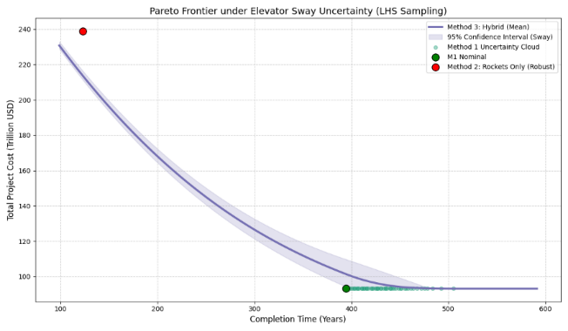

*Figure 5-2. Pareto frontier under tether oscillations*

As the duration increases, the system relies more on the space elevator. Because elevator capacity is randomly affected by the oscillation factor (Y), long-term operation amplifies accumulated random errors, increasing cost uncertainty; thus, the shaded band widens.

The elevator-only scheme (green scatter cloud) shows strong dispersion along the time axis, indicating that under non-ideal conditions, a single-mode strategy leads to uncontrollable completion time (e.g., (390)–(500) years) and poor engineering reliability.

In contrast, the mean curve of Method 3 is stable. Even in the worst case (upper edge of the band), the cost increase remains controllable, showing that the “dual-track parallel” strategy can offset environmental disturbances by dynamically adjusting the rocket–elevator allocation.

To keep the same “marginal willingness to invest” as in the ideal case, we select the point on the mean Pareto curve whose slope matches the original scheme, yielding the following solution.

表5-1. Table 5-1. Optimal decision under tether oscillations

|  |  |  |  |
| --- | --- | --- | --- |
| Mertic | Original ideal plan | Robust decision point | Risk cost |
| Completion time (T) | 150.0 Year | 143.89 Year | −6.11 Year |
| Expected total cost (C) | $192.9 Trillion$ | $199.88 Trillion$ | +$6.98 Trillion |
| Marginal cost slope | −0.6353 T/Y | −0.6366 T/Y | Approximately equivalent |

With elevator-oscillation risk, the expected total cost increases from 192.9T to 199.88T. The additional $6.986.98Trillion is the “risk premium” required to hedge environmental uncertainty.

The duration decreases to 143.89143.89143.89 years. In expectation, as elevator efficiency declines due to oscillations, maintaining a long duration reduces effective output per unit time. To preserve marginal-balance conditions, the model slightly increases the rocket share to “gain time,” ensuring that under a 95% confidence level the project will not be indefinitely delayed by stochastic elevator downtime.

**5.2 Rocket Launch Failure Risk Model**

In a construction-material transport mission lasting hundreds of years, rocket technology may be mature, but random single-launch failures (e.g., ascent explosion, failed orbital capture) remain a non-negligible risk. This model extends the baseline model by introducing a flight failure probability and quantifying the resulting economic loss of payload. We introduce the failure probability $P_{fail}$ ​ and payload unit value $C_{payload}$.

Set the flight failure rate $P_{fail}$ as a fixed value $θ$. Assume $θ$ follows a truncated normal distribution: $θ∼N\left(μ_{θ},σ_{θ}^{2}\right),\text{subjectto}θ≥0,$ where $μ_{θ}=0.01$ means one failure per 100 launches on average, and $σ_{θ}=0.003$.

Since lunar construction requires precise bulk materials, a failure incurs not only launch cost but also the production cost of the materials. We set the payload value ​ as 105USD/t.

If the launch succeeds, the net payload mass $m$ is delivered to the Moon and $M_{acc}←M_{acc}+m$. If the launch fails, the net payload mass $m$ is completely lost and $M_{acc}$ does not increase.

**5.2.1 Mathematical Description of Economic Loss**

The total cost per launch $ΔC$ depends on the flight outcome. With the scale-discount factor $α = 0.2$ we compute:

(a) Successful launch cost, including only the discounted launch cost:

$$\begin{aligned}ΔC_{success}=m⋅c_{unit}⋅\left(1-α⋅\frac{M_{current}}{M_{total}}\right)\#\left(29\right)\end{aligned}$$

(b) Failure loss, including the discounted “sunk” launch cost and the full payload compensation cost:

$$\begin{aligned}ΔC_{failure}=\underset{Sunk launch cost}{\underbrace{m⋅c_{unit}⋅\left(1-α⋅\frac{M_{current}}{M_{total}}\right)}}+\underset{Payload loss cost}{\underbrace{m⋅C_{payload}}}\#\left(30\right)\end{aligned}$$

**5.2.3 Discrete-Event Simulation**

We simulate with a daily time step. Each day, for each mission at each base, generate a random number $r∈\left[0,1\right]$. If $r<P_{fail}$, trigger a Failure event, add $ΔC_{failure}$ to total cost, and do not count delivered mass. If $r ≥ P_{fail}$ , trigger a Success event, add $ΔC_{success}$, and increase delivered mass by the actual payload. The daily total number of attempted launches is constrained by $λ_{max}$ (i.e., a maximum of 2 launches/day).

Based on the discrete-event simulation results, the performance of the three schemes under uncertainty is summarized in the following table:

***Table 5-2. Summary of system performance under launch-failure scenarios***

|  |  |  |  |  |
| --- | --- | --- | --- | --- |
| **Method** | **T** | **C** | **time_kind** | changes |
| M1 | 394.2 | $93.1 | planned | 0 |
| M2 | 123.9 | $240.5 | real | **+1.21 year / +$1.61 T** |
| M3 | 151.47 | $193.7 | real | **+1.47 year / +$0.87 T** |

Launch failures have a compounded effect on cost: even when a launch fails, fuel consumption and hardware depreciation have already occurred, and the $100,000/t payload loss greatly increases the cost of each failure. In Method 3, about 38% of the total payload is transported via the more stable space elevator, so it is less exposed to launch-failure shocks. This shows that the hybrid strategy isolates risk by allocating high-value or critical materials to the elevator, thereby reducing the system-wide risk premium.

Even when failures occur, failed launches are still counted in the “total attempted launches,” allowing the system to accumulate operational experience. This partly offsets the additional economic pressure from re-shipping payloads, reflecting how technological maturity can hedge risk in long-term engineering projects.

**5.3 Stochastic Failure Queueing Model Based on Heterogeneous Rocket Infrastructure**

**5.3.1 Model Assumptions and Definitions**

To simulate the realistic operating dynamics of the global rocket-launch network, we use a discrete-event simulation framework with the following core assumptions:

**Infrastructure heterogeneity:** The global $N=10$ launch bases are divided into three tiers (Modern, Standard, Legacy) by technology gap. Each tier has distinct mean time between failures (MTBF) and mean time to repair (MTTR).

**Non-recoverable launch windows:** The maximum daily capacity is limited by the daily launch-frequency cap (2 launches/day). If a failure occurs on a given day, that day’s capacity is permanently lost and cannot be fully recovered by simple “overtime” later.

**Failure independence:** Failure events between any two bases are statistically independent and do not affect each other.

**Stochastic process properties:** Failure occurrences follow a Poisson process, and repair times follow a truncated normal distribution.

**5.3.2 Model Formulation**

Let $S_{j}\left(t\right)$ denote the operational state of base j on day t:

$$\begin{aligned}S_{j}\left(t\right)=\left\{\begin{aligned} 1, & Available \\ 0, & Under Maintenance \end{aligned}\right.\#\left(31\right)\end{aligned}$$

With a discrete time step $Δt = 1$ day, if base $j$ is in the normal state, the probability of failure on the next day $P_{fail,j}$ depends on its tier characteristics:

$$\begin{aligned}P\left(S_{j}\left(t+1\right)=0 ∣ S_{j}\left(t\right)=1\right)=1-e^{-\frac{1}{{\text{MTBF}}_{j}}}≈\frac{1}{{\text{MTBF}}_{j}}\#\left(32\right)\end{aligned}$$

Once a failure is triggered, the base enters maintenance. The repair duration $τ_{\text{repair},j}$ follows a truncated normal distribution:

$$\begin{aligned}τ_{\text{repair},j}∼\max\left(1,\left\lfloor N\left({\text{MTTR}}_{j},{\left(0.2⋅{\text{MTTR}}_{j}\right)}^{2}\right)\right\rfloor \right)\#\left(33\right)\end{aligned}$$

During this period, $S_{j}\left(t+k\right)=0$, and the base has no capacity output.

The long-run theoretical availability $A_{j}$ is defined as:

$$\begin{aligned}A_{j}=\frac{{\text{MTBF}}_{j}}{{\text{MTBF}}_{j}+{\text{MTTR}}_{j}}\#\left(34\right)\end{aligned}$$

Due to infrastructure heterogeneity, the 10 global launch bases are divided into three tiers—Modern, Standard, and Legacy—and assigned different MTBF and MTTR values, as shown in the table below:

*Table 5-3. Simulation parameter settings for different base tiers*

|  |  |  |  |  |  |
| --- | --- | --- | --- | --- | --- |
| Characteristics | Base | MTBF (d) | MTTR (d) | Risk | Availability |
| Modern | Starbase, Mahia | 300 | 1 | Low | 99.70% |
| Standard | Kourou, Taiyuan | 200 | 2 | Mid | 99.00% |
| Legacy | Baikonur, Cape Canaveral | 140 | 4 | high | 97.20% |

**5.3.3 Objective Function and Evaluation Metrics**

Total project duration: The total number of days ${ T}_{\text{finish}}$ required to complete the total task volume $M$ is

$$\begin{aligned}T_{\text{finish}}=\min\left\{T ∣ \sum_{t=1}^{T}{\left(\sum_{j=1}^{N}{W_{j}\left(t\right)}⋅S_{j}\left(t\right)\right)}≥M\right\}\#\left(35\right)\end{aligned}$$

Stochastic cost with scale discount: Cost is computed by dynamically integrating with real-time progress. The cost on day $t$, $ΔC\left(t\right) ,$ is

$$\begin{aligned}ΔC\left(t\right)=\sum_{j=1}^{N}{w_{j}\left(t\right)}⋅c_{\text{dry},j}⋅\left(1-α⋅\frac{M_{\text{acc}}\left(t\right)}{M}\right)\#\left(36\right)\end{aligned}$$

where ${ M}_{\text{acc}}\left(t\right)$ is the cumulative delivered mass, and $α$ is the scale-discount factor, $α=0.2$.

By leveraging the reserved capacity redundancy of the system (the gap between the upper limit and the average demand), the model offsets the “downtime loss” caused by base maintenance. This keeps the simulated completion time closer to the expected target and effectively prevents systemic delays induced by random failures.

**5.3.4 Model Solution**

Based on simulation runs with fixed seeds, the actual performance of the three schemes under random launch-base failures is shown in Table 5-4. The non-recoverable nature of launch windows causes a systemic loss of progress. Even the hybrid scheme M3 incurs a (3.61)-year delay.

*Table 5-4. Summary of system performance under launch-base failure scenarios*

|  |  |  |  |  |
| --- | --- | --- | --- | --- |
| Method | T | C | Time_kind | Changes |
| M1 | 394.2 | $93.1 | planned | 0 |
| M2 | 122.7 | $237.4 | real | +2.96 年 (+2.4%) |
| M3 | 153.6 | $191.5 | real | +3.61 年 (+2.4%) |

**5.4 Elevator Mechanical Failures and Dynamic Rocket Backfill Model**

In long-term missions, the space elevator may experience random downtime due to tether wear, climber maintenance, or debris-avoidance maneuvers. This model evaluates the reliability of the elevator system and simulates the dynamic response of the ground rocket system as an “emergency backup.”

**5.4.1 Stochastic Process of Elevator Failures**

Introduce the elevator state variable $S_{E}\left(t\right)$ to describe its operating status on day $t$:

$$\begin{aligned}S_{E}\left(t\right)=\left\{\begin{aligned} 1, & Operation \\ 0, & Down/Repair \end{aligned}\right.\#\left(37\right)\end{aligned}$$

Assume elevator failures follow a Poisson process. If the elevator is currently operating, the probability of failure on the next day is

$$\begin{aligned}{P ( S}_{E}\left(t+1\right) = 0 ∣S_{E}\left(t\right) = 1) ≈ \frac{1}{{\text{MTBF}}_{E}}\#\left(38\right)\end{aligned}$$

Once down, the repair time $τ_{\text{repair}}$ follows a truncated normal distribution:

$$\begin{aligned}τ_{\text{repair}}∼\max\left(1,\left\lfloor N\left({\text{MTTR}}_{E},σ^{2}\right)\right\rfloor \right)\#\left(39\right)\end{aligned}$$

${\text{MTBF}}_{E} = 300$ days， ${\text{MTTR}}_{E}=7 \text{d}\text{ays}, σ=2$，During downtime, the elevator capacity drops to 0.

**5.4.2 “Rocket Backfill” Logic in the Hybrid Scheme**

In Method 3 (hybrid transport), the system adopts a dynamic policy of “elevator first, rockets as backup.”

At $t =2$, under ideal conditions, the planned elevator payload $m_{ele,plan}$ and planned rocket payload $m_{roc,plan}$ are set. However, due to downtime and repair, the elevator’s actual completed payload by the end of the project duration $T$ is

$$\begin{aligned}m_{ele,actual}=\sum_{t=1}^{T⋅365}{\left(m_{ele,plan} / 365⋅S_{E}\left(t\right)\right)}\#\left(40\right)\end{aligned}$$

The system identifies the resulting transport shortfall $m_{gap}$ and shifts it to the rocket system:

$$\begin{aligned}m_{roc,total_needed}=m_{roc,plan}+\underset{m_{gap}}{\underbrace{\left(m_{ele,plan}-m_{ele,actual}\right)}}\#\left(41\right)\end{aligned}$$

This ensures that even with elevator failures, the total construction task $M$ can still be completed on schedule.

**5.4.3 Cost Integral Model with Scale Effects**

As the backfill logic changes the total rocket-transport volume, we use a continuous integral to compute the scale discount precisely.

Let $P_{\text{base}}$ be the weighted-average base unit price of rockets (from heterogeneous base parameters), $s$ be the scale-discount coefficient （$s=0.2$）, and ${ M}_{\text{total}}$ be the total project mass target. The total rocket cost for transporting $m$ tons, ${ C}_{\text{roc}}\left(m\right)$, is the definite integral of the unit-price function:

$$\begin{aligned}C_{\text{roc}}\left(m\right)=\int_{0}^{m}{P_{\text{base}}\left(1-s⋅\frac{x}{M_{\text{total}}}\right)dx}\#\left(42\right)\end{aligned}$$

The closed-form solution is:

$$\begin{aligned}C_{\text{roc}}\left(m\right)=P_{\text{base}}\left(m-\frac{s⋅m^{2}}{2⋅M_{\text{total}}}\right)\#\left(43\right)\end{aligned}$$

Under this formula, when rockets must carry more tasks due to elevator failures ( $m$ increases), total spending rises, but the unit transport cost decreases further due to scale effects.

**5.4.4 Model Solution**

Based on the simulation results (Table 5-5), with an average elevator availability of about (97.7%), the schemes perform as follows.

*Table 5-5. Summary of system performance under elevator random-failure scenarios*

|  |  |  |  |  |
| --- | --- | --- | --- | --- |
| Method | T | C | Time_kind | Changes |
| M1 | 403.0 | $93.1 | real | **+8.85 years (+2.2%)** |
| M2 | 122.7 | $238.9 | planned | 0 |
| M3 | 150.0 | $193.7 | real | **+0.88 years (+0.46%)** |

This model uses system redundancy to hedge risk. The elevator-only mode has no backup, so any failure causes a standstill; the simulation shows that (97.7%) availability extends the duration from (394) years to (403) years, demonstrating the fragility of a single route under mechanical fatigue. The hybrid scheme introduces hard constraints and a backfill logic: once the elevator fails, the shortfall is automatically reassigned to rockets. Under the cost integral model, the additional backfill volume moves rockets further along the learning curve and triggers deeper scale discounts, and this endogenous compensation mechanism effectively mitigates the economic pressure caused by failures.

**5.5 Summary**

In Model 2, we move from an ideal physical environment to a realistic engineering environment with stochasticity, and simulate four core failure scenarios. By dynamically correcting the Pareto frontier and applying the “equal-slope matching strategy,” we obtain the following insights into the resilience of the transportation system.

**5.5.1 Systematic Shift of the Pareto Frontier**

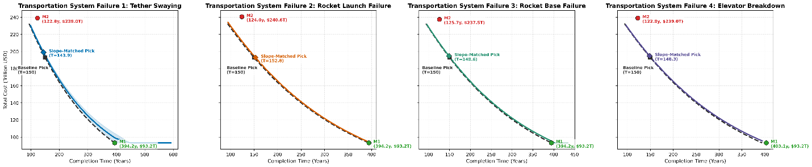

*Figure 5-3. Pareto frontiers under four core failure scenarios*

As shown in Figure 5-3, all four failure modes cause the Pareto frontier to “shift right” and/or “shift upward” relative to the ideal baseline, to varying degrees. Elevator oscillations not only increase cost but also significantly widen the frontier band, indicating high sensitivity to environmental disturbances. With payload-value compensation included, the frontier under launch failures rises most steeply, showing that catastrophic failures are the primary source of the system’s economic risk premium. Launch-base failures and elevator downtime mainly affect the time dimension: due to the “window-loss effect,” the originally tight plan exhibits a clear progress deficit under random maintenance shocks.

**5.5.2 Robust Decisions: Adjustment via Marginal-Cost Equivalence**

To answer “how much the plan should be adjusted under non-ideal conditions,” we adopt the equal-slope selection rule. The slope represents the “marginal substitution rate between time and money.” Keeping the slope unchanged means maintaining the same “willingness to invest” as the original plan under risk.

*Table 5-6. Summary of robust decision shifts under different failure scenarios*

| **Failure scenario** | **Robust decision point** | **Expected total cost** | **Schedule shift** | **Cost premium** |
| --- | --- | --- | --- | --- |
| Baseline (ideal) | 150.0 | 192.9 | – | – |
| Elevator oscillation | 143.9 | 199.9 | −6.1 | +7.0 |
| Launch failure | 152.8 | 194.5 | +2.8 | +1.6 |
| Random base failures | 148.6 | 193.5 | −1.4 | +0.6 |
| Elevator mechanical downtime | 148.3 | 194.2 | −1.7 | +1.3 |

At the 95% confidence level, to handle combined stochastic risks, the system should reserve 2%–5% schedule redundancy. The system shows strong robustness: through “dual-track complementarity” and “dynamic backfill logic,” the hybrid scheme keeps the average total-cost increase within 0.5%–3.5%. The equal-slope analysis confirms that the hybrid strategy is dominant across all failure scenarios. Even under partial system stoppages, it can minimize losses via path switching.

**6. Model 3： Dual-Track Water Supply Model Based on Hybrid Dynamic Programming**

Water is the most fundamental resource in the ecological cycle. We investigated the total water resources required to sustain the operation of a lunar colony of 100,000 people for one year after its completion. Providing water for a colony of 100,000 is a key logistical task, characterized by high frequency, zero tolerance for delays, and strict physical constraints.

To evaluate the time and cost of water supply, we developed a hybrid dynamic programming-based dual-track water supply model. This model uses precise dynamic programming methods to solve the optimal control strategy for the colony's initial survival period.

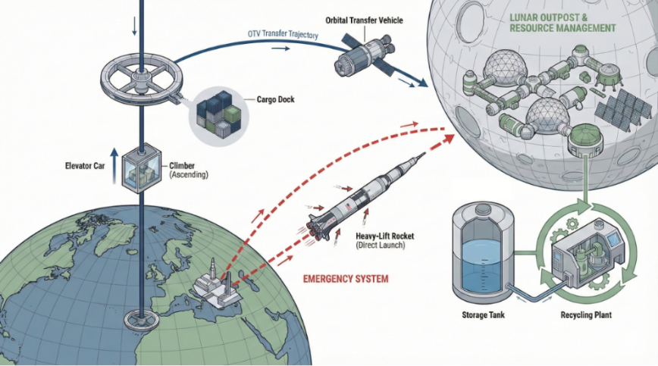

*Figure 6-1. Schematic of the dual-track water supply model*

**6.1 Model Background and Assumptions**

This model addresses the water supply issue during the early operational phase of the lunar colony (Day 1 - Day 365), following the completion of the 100 million-ton infrastructure task, using existing logistics infrastructure for transportation.

1）Discrete Batch Assembly: The apex anchor is treated as an "orbital assembly plant." The space elevator continuously delivers materials (structure, fuel, water), but goods must accumulate at the apex anchor to meet the physical requirements of the transport rocket (TR) before launching. A TR must first meet dead weight (structure + fuel for full load), with the remaining accumulated mass converted into payload (net water).

2）Dual-Track Game: The conventional track (SE + TR) has low cost but suffers from accumulation delays. Elevator capacity takes time to convert into payload. The emergency track (GR) uses ground rockets, which are expensive but have immediate response and do not consume materials at the apex anchor.

3）Dynamic Cold Start: The system starts with an empty state at t=0. The model does not predefine actions for t=1 but sets a hard constraint that survival must be achieved by t=1, forcing the dynamic programming algorithm to derive the optimal solution.

4）Hard Cutoff Logic: If the inventory falls below 1800 tons, it is considered a violation, triggering a large penalty and forcing the algorithm to act immediately rather than waiting until inventory reaches zero.

**6.2 Variable Definitions and Parameter Calculation**

**6.2.1 State Variables**

The system state at time t is represented by the tuple $S_{t}=\left(I_{t},M_{t}\right)$:

$I_{t}$ ∈R: The actual available water resource stock on the lunar surface (tons). $M_{t}∈\left[0,L_{\text{MAX}}\right]$: The total accumulated mass at the apex anchor (tons), including structure, fuel, and water. After launch, $M_{t}$ is reset or reduced.

**6.2.2 Decision Variables**

At time t, the control policy $π\left(S_{t}\right)$ selects an action $a_{t}∈A$:

$a_{t}=\text{Wait}$: Charging mode. The elevator runs at full speed, but no TR is launched.

$a_{t}=\text{OTV}$: Regular launch. Materials accumulated at the apex anchor are assembled into a TR for launch, selectable only when $M_{t}>M_{\text{dead}}$.

$a_{t}=\text{GR}$: Emergency launch. Ground rockets replenish stock, and the elevator continues operating.

**6.2.3 Physical and Cost Parameter Calculation**

Based on the Tsiolkovsky rocket equation, the TR payload is nonlinear, with a "threshold effect":

TR mass amplification factor:

$$\begin{aligned}κ_{A}=\exp\left(\frac{Δv_{\text{TR}→\text{Moon}}}{I_{sp,A}⋅g_{0}}\right)⋅\left(1+α_{A}\right)\#\left(44\right)\end{aligned}$$

$M_{\text{dead}}$ represents the minimum dead weight required for the TR (structure + fuel):

$$\begin{aligned}M_{\text{dead}}=L_{\text{MAX}}⋅\left(1-\frac{1}{κ_{A}}\right)\#\left(45\right)\end{aligned}$$

For the current accumulated mass m, the transportable net water w(m) is:

$$\begin{aligned}w\left(m\right)=\left\{\begin{aligned}0 , m ≤M_{\text{dead}} \\ m-M_{\text{dead}},M_{\text{dead}}<m<L_{\text{MAX}} \\ L_{\text{MAX}}-M_{\text{dead}},m≥L_{\text{MAX}}\end{aligned}\right.\#\left(46\right)\end{aligned}$$

The first $M_{\text{dead}}$ tons of materials are used to construct the rocket itself, with only the excess being water. For base j, the payload capacity of a single ground rocket is given by $Q_{j}=\frac{L_{\text{MAX}}}{\exp\left(\frac{Δv_{j}}{I_{sp,E}⋅g_{0}}\right)⋅\left(1+α_{E}\right)}.$

**6.3 System Dynamic Evolution Equation**

The change in lunar stock is determined by consumption, recycling, TR arrivals, and GR arrivals:

$$\begin{aligned}I_{t+1}=I_{t}+\underset{\text{Net Consumption}}{\underbrace{{{ηD}_{t-3}-D}_{t}}}+\underset{\text{TR Arrival}}{\underbrace{q_{TR}\left(a_{t},M_{t}\right)}}+\underset{\text{GR Arrival}}{\underbrace{q_{GR}\left(a_{t}\right)}}\#\left(47\right)\end{aligned}$$

Where $D_{t}$ represents the actual water demand on day $t$ (a random variable, normally distributed as $N\left(1000,100\right)$ tons); $η$ represents the water recycling efficiency, set at 0.98 (98% recycling rate); $τ_{\text{rec}}$ represents a 3-day recycling delay.

If $a_{t}=\text{TR}$, then $q_{TR}=w\left(M_{t}\right)$; otherwise, it is 0.

If $a_{t}=\text{GR}$, then $q_{GR}=\sum_{j}{k_{j}^{*}Q_{j}}$ (where $k_{j}^{*}$ is the optimal launch combination); otherwise, it is 0.

The change in the accumulated mass at the apex anchor depends on elevator inflow and launch clearing.

$$\begin{aligned}M_{t+1}=\left\{\begin{aligned}M_{t}+Cap_{SE},\text{if }a_{t}∈\{\text{Wait, GR}\} \\ 0,\text{if }a_{t}=\text{TR} \text{(Assuming All Launches or Clearances)}\end{aligned}\right.\#\left(48\right)\end{aligned}$$

When GR is selected, the elevator continues to operate in the background, and $M_{t}$ continues to increase. This reflects the "time-for-money" value of the GR strategy—protecting the accumulation progress of TR.

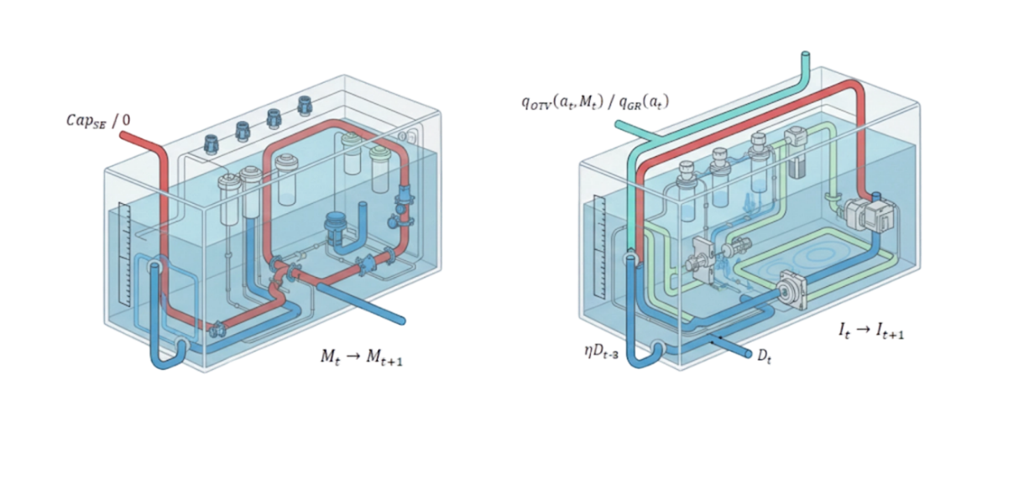

*Figure 6-2. Diagram of System Dynamic Evolution Equation*

**6.4 Dynamic Programming Decision Logic**

We need to solve the optimal value function $V_{t}\left(I,M\right)$, representing the minimum accumulated cost from time t to the end, based on the Bellman equation:

1) Action A: Wait (Charging): Only the elevator runs, and no TR is launched. The cost is $C_{\text{now}}=Cap_{\text{SE}}⋅c_{\text{lift}}$, applicable when inventory is safe and the TR is not yet fully accumulated.

2) Action B: Launch TR (Regular Launch): Launch the TR with the current accumulated $M_{t}$, only when $M_{t}>M_{\text{dead}}$. The cost is $C_{\text{now}}=C_{\text{fixed}}^{\text{TR}}+Cap_{\text{SE}}⋅c_{\text{lift}}.$ ​ If $M_{t}≈L_{\text{MAX}}$ (full load), the cost per ton of water is minimized; if $M_{t}≈M_{\text{dead}}$ (half load), the cost per ton is extremely high. DP automatically calculates whether it is worth accepting the high unit price for urgent needs.

3) Action C: Launch GR (Ground Emergency): Use ground rockets to replenish inventory to $I_{\text{target}}$ (or fill the gap), considering the scheduling subproblem.

$$\begin{aligned}C_{\text{GR}}^{*}=\min{\sum_{j}{k_{j}C_{\text{fixed}}^{\text{GR},j}}} \text{s.t.}\sum_{j}{k_{j}Q_{j}}≥\max\left(0,I_{\text{target}}-I_{t}\right)\#\left(50\right)\end{aligned}$$

The cost is $C_{\text{now}}=C_{\text{GR}}^{*}+Cap_{\text{SE}}⋅c_{\text{lift}}$. Although expensive, it prevents inventory from being depleted. If nearing full load, DP tends to select this action to protect the full load benefit of TR. $I_{\text{target}}$ is the target inventory upper limit $\left(I_{\text{nom}}+C_{\text{TR}}\right)$, marking the stopping point for elevator operation.

**6.5 Mathematical Modeling and Solution**

The objective of full-cycle optimization is to minimize the total expected cost:

$$\begin{aligned}\min_{π}{E}\left[\sum_{t=1}^{T}{\left(I_{SE}C_{lift}+I_{TR}C_{fixed}^{TR}+I_{GR}C_{GR}^{*}\right)}+\sum_{t=1}^{T}{\text{Penalty}\left(I_{t}\right)}\right]\#\left(53\right)\end{aligned}$$

Summary of constraints:

1. Non-negative inventory: $I_{t}≥0$   (enforced via an ∞ penalty).

2. Apex-anchor physical constraint:.

3. TR assembly constraint: only when

4. Cold-start constraint: $I_{1}≥I_{\text{nom}}$.

We then solve the model using dynamic programming and obtain the following results:

Table 6-1 lists the key logistics events over the 365-day cycle. The task is clearly divided into two phases: an expensive initialization phase (Phase I) and an efficient steady-state maintenance phase (Phase II).

**Table 6-1. Key Operational Events and Cost Breakdown**

| **Phase** | **Time** | **Action type** | **Launch details** | **Delivered payload** | **Phase cost** | **Notes** |
| --- | --- | --- | --- | --- | --- | --- |
| I. Cold start | Day 1 | GR (emergency) | All 10 global bases at full load (20 launches) | 2,231.8 t | $216.6 B | Establish Day-1 survival baseline |
| Day 2 | GR (emergency) | 9 bases at high load (19 launches) | 1,905.2 t | $184.1 B | Reinforce safety stock |
| Day 3 | GR (emergency) | 5 bases at medium load (10 launches) | 1,128.1 t | $108.3 B | Complete initial stock buildup |
| II. Steady-state cycle | Day 15 | OTV (routine) | Full-load launch (Full Load) | 2,834.0 t | $2.2 B | First elevator-assembly batch |
| Day 60 | OTV (routine) | Full-load launch (Full Load) | 2,834.0 t | $2.2 B | Periodic resupply |
| ... | ... | ... | ... | (on average once every 45 days) | |
| Day 363 | OTV (routine) | Full-load launch (Full Load) | 2,834.0 t | $2.2 B | Year-end resupply |
| Total | 1 Year | Mixed | 3 days GR + 9 OTV launches | ~34,000 t | $506.75 B | GR accounts for 96% of total cost |

The simulation is visualized as an inventory-dynamics curve and a cumulative-cost curve, as shown in Figure 6-3.

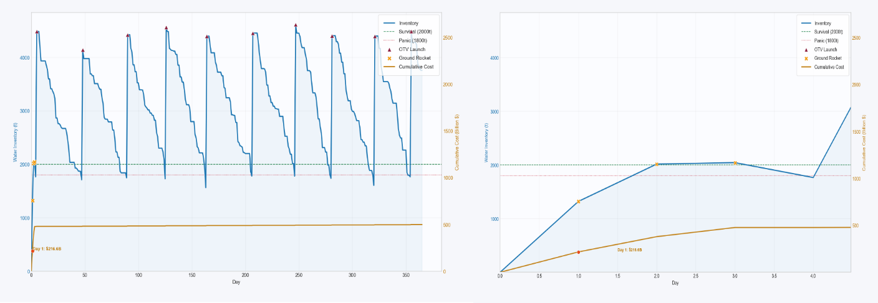

Figure 6-3. Inventory Dynamics Curve and Accumulated Cost Curve with Subplots

The inventory dynamics curve shows a sawtooth pattern. The descending slope represents the colony's daily net water consumption. The vertical rise represents supply arrivals, with each significant vertical lift corresponding to a TR arrival. This proves the effective operation of the apex anchor’s "batch assembly" mechanism—efficient supply is only released once 6000 tons are accumulated.

Cold Start Surge: From t=0 to t=3, three consecutive orange crosses indicate GR intervention. With an initial inventory of 0 and $I_{nom}$ = 2000 tons, the DP algorithm is forced to launch all available rockets for "saturation rescue" on Day 1, rapidly raising the inventory above the safety threshold.

Initial Wall: From Day 1 to Day 3, the cost curve rises almost vertically, reaching about $500 billion, meaning 99% of the yearly budget is spent in the first 3 days. This represents the "startup cost" required to overcome the physical dilemma of I_0 = 0.

Plateau Period: Starting from Day 4, the curve flattens, showing the significant cost advantage of TR over GR. Once the survival crisis is over, the cost of steady-state supply using the elevator is nearly negligible compared to the first three days.

Initial Construction is the Key Cost Decision Point: The simulation shows that the cost to maintain water resources for one year is about $506.7 billion. However, $50.9 billion is spent solely to establish the initial inventory from zero. If the colony has already accumulated 2000 tons of water through other means before operation, the cost for one year drops drastically to $20 billion (requiring only 9 TR launches).

**Ⅶ. Model 4：Life Cycle Social Cost Quantification Model**

To comprehensively quantify the ecological cost of human "interstellar migration," we have developed a life cycle social cost model. This model goes beyond simply calculating financial expenditures and incorporates the economic principle of "internalizing externalities," converting environmental damage into equivalent monetary costs.

Using this model, we will construct a new generalized objective function Z, aiming to find a "green optimal solution" that both realizes the vision of lunar colonization and maximally protects our Mother Earth.

**7.1 Core Logic and Boundary Definition of the Model**

Air Pollution Boundary: Only traditional rockets are considered. Space elevators have no emissions during operation; the exhaust of the elevator's second-stage rocket operates in the vacuum of deep space tens of thousands of kilometers away, and its exhaust does not return to damage Earth's atmosphere.

Resource Consumption Boundary: Covers all stages. Whether it's a ground-launched rocket or a second-stage rocket ferrying in space, its fuel and materials come from Earth's finite resources. It is assumed to be a "one-way journey," meaning these materials are permanently discarded in space, leading to 100% resource depletion.

Energy Carbon Footprint: Focuses on calculating the implicit emissions from the elevator's power source and the long-term maintenance costs of the infrastructure.

**7.2 Objective Function and Model Solution**

$$\begin{aligned}\text{Minimize }Z=C_{\text{Finance}}+\left(C_{\text{Amshr}}+C_{\text{Rsuc}}+C_{\text{Idrc}}\right)⋅Φ\left(T\right)\#(60)\end{aligned}$$

$Φ\left(T\right)$ represents the project duration penalty term; all cost items are converted to 2050 USD; $C_{\text{Finance}}$ refers to the cost in the original model.

**7.2.1 Cost of Atmospheric Environmental Damage**

Atmospheric Damage Cost is subdivided into three parts: greenhouse effect and stratospheric black carbon forcing.

$$\begin{aligned}C_{\text{Atmosphere}}=C_{\text{GHG}}+C_{\text{BlackCarbon}}\#\left(61\right)\end{aligned}$$

Greenhouse Gas Cost: Global warming cost from CO2 emissions during rocket fuel combustion.

$$\begin{aligned}C_{\text{GHG}}=\left(\sum_{j∈J}{n_{j}}⋅μ_{\text{fuel},E}\right)×{\text{EF}}_{{\text{CO}}_{2}}×{\text{SCC}}_{2050}\#\left(62\right)\end{aligned}$$

$μ_{\text{fuel},E}$ ​ represents the fuel consumption per unit payload for ground rockets; ${\text{EF}}_{{\text{CO}}_{2}}$ is the emission factor, indicating the CO2 mass produced per kilogram of fuel burned. For RP-1 or methane, ${\text{EF}}_{{\text{CO}}_{2}}$ is 3.0 (kg CO2/kg fuel); ${\text{SCC}}_{2050}$ represents the social cost of carbon, the long-term economic loss caused by the emission of one ton of CO2 to society. The current SCC is about 50-100 $/ton, and by 2050, it may rise to 200-500 $/ton, with a median estimate of 300 $/ton according to the NGFS "Net Zero 2050" scenario.

Stratospheric Black Carbon Radiative Forcing Cost: Kerosene engines produce black carbon, which is a strong absorber of heat. The black carbon particles left by rockets in the stratosphere have high absorption capacity and remain in the upper atmosphere for a long time, causing more harm than ground-level emissions.

$$\begin{aligned}C_{\text{BC}}=\left(\sum_{j∈J}{n_{j}}⋅μ_{\text{fuel},E}\right)×{\text{EF}}_{\text{BC}}×{\text{GWP}}_{\text{BC}}×Ψ_{\text{strato}}×{\text{SCC}}_{2050}\#\left(63\right)\end{aligned}$$

${\text{EF}}_{\text{BC}}$ represents the fraction of black carbon particles generated by incomplete fuel combustion, typically 2-4%, taken as 2%. ${\text{GWP}}_{\text{BC}}$ represents the global warming potential of black carbon, set at 360. The greenhouse effect of pollutants in the stratosphere is magnified compared to the surface, with $Ψ_{\text{strato}}$ representing the stratospheric residence amplification factor. Climate models suggest that radiative forcing effects in the upper atmosphere are 2 to 4 times those at the surface, taken as 2.5.

**7.2.2 Earth Resource Depletion Cost**

The intergenerational compensation tax for fossil energy is:

$$\begin{aligned}C_{\text{Fuel}\text{_}\text{Tax}}=\left(\underset{\text{地面火箭耗油}}{\underbrace{\sum_{j}{n_{j}}⋅μ_{\text{fuel},E}}}+\underset{\text{电梯转运火箭耗油}}{\underbrace{\sum_{i}{m_{i}}⋅μ_{\text{fuel},A}}}\right)×{\text{Tax}}_{\text{scarcity}}\#\left(65\right)\end{aligned}$$

$μ_{\text{fuel},G}$ represents the fuel consumption per unit payload for transport rockets; ${\text{Tax}}_{\text{scarcity}}$ represents the oil scarcity tax, an additional resource tax on the consumption of non-renewable fossil energy, compensating for the loss of resources unavailable to future generations. Assuming oil depletion by 2050, with a scarcity tax of 50%-100% of the market price, and an estimated fuel price of $600-$800/ton, a $500/ton tax reflects the strong sustainability principle.

**7.2.3 Indirect Environmental Cost**

$$\begin{aligned}C_{\text{Indirect}}=C_{\text{Elec}\text{_}\text{Footprint}}+C_{\text{Maint}}\#\left(67\right)\end{aligned}$$

Electricity Carbon Footprint: Multiply the total energy consumption of the elevator system (calculated in the original model) by the carbon intensity of the 2050 power grid.

$$\begin{aligned}C_{\text{Elec}\text{_}\text{Footprint}}=E_{\text{total}\text{_}\text{kWh}}×{\text{CI}}_{\text{grid}}×{\text{SCC}}_{2050}\#\left(68\right)\end{aligned}$$

$E_{\text{total}\text{_}\text{kWh}}$ represents the total energy consumption of the elevator system, calculated as $\sum{m_{i}}⋅κ_{A}⋅Δε/η_{E}$; ${\text{CI}}_{\text{grid}}$ represents the carbon intensity of the 2050 power grid, indicating the CO2 emissions per kilowatt-hour of electricity produced globally. By 2050, the global energy structure will be deeply decarbonized, primarily relying on renewable energy with minimal peak-shaving coal power, set at 0.05 kg/kWh.

Environmental Share of Infrastructure Maintenance: Space elevators and launch sites require continuous maintenance, and these activities themselves are sources of carbon emissions.

$$\begin{aligned}C_{\text{Maint}}=T×\left(\sum_{i=1}^{3}{{\text{Maint}}_{\text{Elevator}}}+\sum_{j=1}^{10}{{\text{Maint}}_{\text{Base}}}⋅δ_{\text{usage},j}\right)×{\text{SCC}}_{2050}\#\left(69\right)\end{aligned}$$

${\text{Maint}}_{\text{Elevator}}$ represents the annual maintenance emissions of the elevator. 5% of the tether material must be replaced annually due to micro-meteorite impacts and atomic oxygen corrosion. The total weight of the super tether supporting 179,000 tons/year capacity is $M_{\text{tether}}$ ≈ 150,000 tons. The replacement amount is 7,500 tons/year, with carbon fiber production having a high carbon footprint (30 tCO2/t), so ${\text{Maint}}_{\text{Elevator}}$ = 7,500 × 30 = 225,000 tons CO2/year.

${\text{Maint}}_{\text{Base}}$ represents the annual maintenance emissions of the launch site. To maintain a spaceport (cement repair, liquid nitrogen production, personnel commuting), each active base generates about 106 tons CO2/year. $δ_{\text{usage},j}$ represents the base activation coefficient. If the model decides not to use a base (e.g., high-latitude base), this value is 0 (sequestered state).

**7.2.4 Model Solution**

Based on simulation data, we created a Pareto curve incorporating environmental costs.

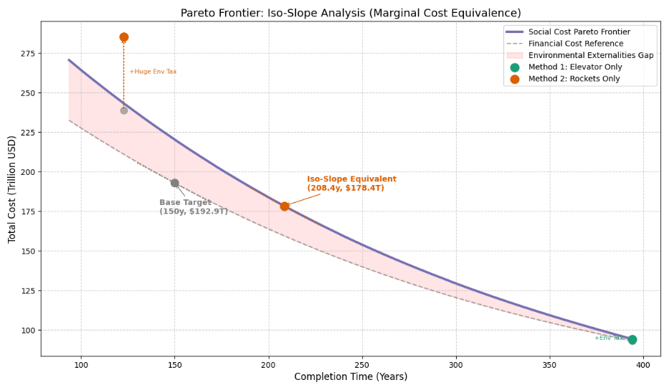

Figure 7-1. Pareto Curve with Environmental Costs

The slope represents the "time-money trade-off." The base model’s slope at T=150 is -0.6364, meaning shortening the project by 1 year requires an additional $0.636 trillion. After incorporating social externalities, maintaining the same "willingness to invest," the optimal balance point is pushed to 208.4 years.

The pink area of the Pareto curve reveals the significant gap between financial costs and total social costs. When the project duration is shorter, environmental costs increase exponentially due to the heavy use of fossil fuel rockets.

At the equal-slope point (T=246.2), where the curve flattens, the total social cost is even lower than the pure financial cost at a faster pace. This strongly demonstrates that by moderately extending the project timeline, we not only protect the environment but also achieve better economic efficiency from a total societal wealth perspective.

Table 7-1. Summary of Core Results Comparison

|  |  |  |  |
| --- | --- | --- | --- |
| Inicator | Base Financial Goal | Social Cost Equal-Slope Point | Change / Difference |
| Completion Time | 150.0 Year | 208.4 Year | +58.4 Year (+38.9%) |
| Total Cost | $192.9 Trillion | $178.4 Trillion | −$14.5 Trillion (−7.5%) |
| Marginal Cost Slope | -0.6364 T/Year | −0.6366 T/Year | Nearly identical (marginally equivalent) |

We used a stacked area chart to visually demonstrate the evolution mechanism of environmental impact, as shown in Figure 7-2.

In the T<200 years range, atmospheric damage is the primary non-financial cost. As the project duration approaches 208.4 years, the system reduces the proportion of high-pollution rockets and relies more on clean space elevators. The zoomed-in chart shows the critical point at T=208.4. At this point, marginal environmental benefits and marginal time losses reach a precise dynamic balance, marking the entry of the Earth-Moon logistics chain into the "green operation zone."

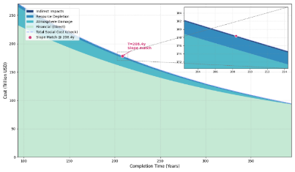

Figure 7-2. Life Cycle Social Cost Composition

This study, using equal-slope analysis, finds that the marginal cost equivalence point shifts to 208.4 years, extending the project duration by about 39%, but reducing total societal costs by approximately $14.5 trillion. This proves that in large-scale deep space infrastructure planning, the strategy of exchanging time for environmental space offers higher long-term social value.

**7.3 Sensitivity Analysis**

To assess the stability and reliability of the integrated lunar orbital logistics model and life cycle social cost model under future uncertainties, we conducted a comprehensive sensitivity analysis. By perturbing core input parameters, we aimed to identify the key factors driving total cost changes and verify whether our strategic recommendations hold under different future scenarios.

**7.3.1 Parameter Selection**

We selected 10 representative parameters across four dimensions—policy, science, technology, and engineering—to comprehensively reflect the uncertainties faced in 2050. The parameters are grouped into the following four themes:

Macro Strategy & Policy: Time pressure ($δ$) represents mission urgency; carbon social cost (SCC) defines the "price of pollution."

Scientific Uncertainty: Stratospheric amplification factor (Ψ) and ozone depletion social cost (SCO3) fill gaps in high-altitude atmospheric chemistry knowledge.

Technological Evolution: Rocket specific impulse (*Isp*) and structural coefficient (α) track the limits of propulsion systems and material science; elevator system efficiency ($ηE$) tests tether system performance.

Engineering & Market: Scale discount factor, black carbon generation rate, and electricity price simulate economic laws and operational fluctuations.

**7.3.2 Analysis Method**

We used the One-At-a-Time (OAT) method. The key innovation is that we didn’t simply extrapolate linearly; instead, we re-ran the full physical optimization model for each parameter change. This ensured that the analysis captured the nonlinear coupling between physical payload limits (e.g., rocket payload capacity) and economic outcomes (e.g., optimal completion time). Each parameter fluctuated within ±50% of its baseline value.

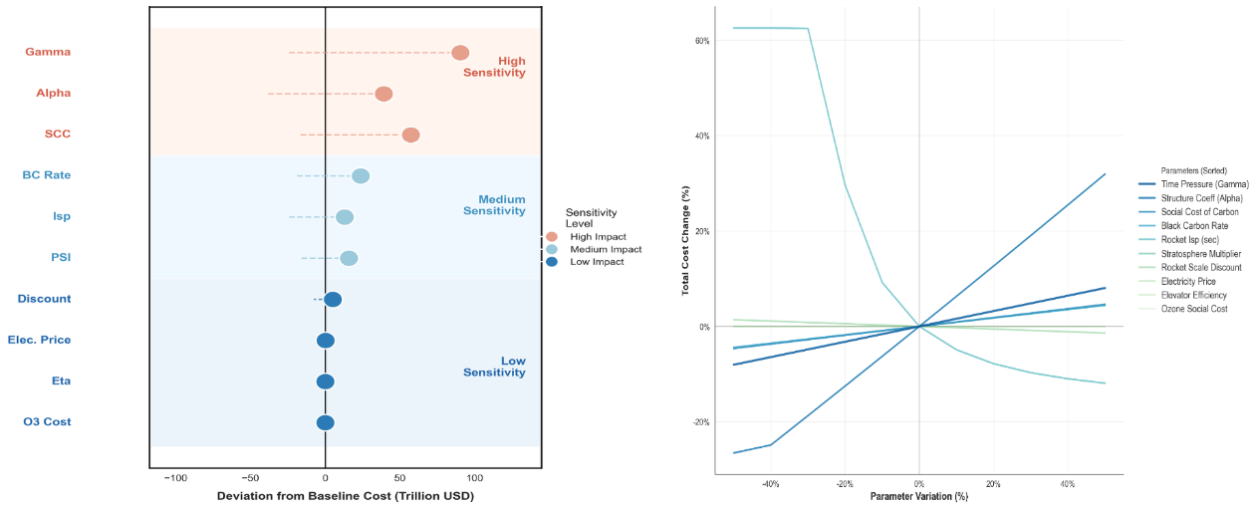

Figure 7-3. Layered Dumbbell Chart and Perturbation Line Chart

Figure 7-3. Layered Dumbbell Chart and Perturbation Line Chart

Left (Dumbbell Chart): The absolute deviation of each parameter’s impact on baseline cost is ranked:

High Sensitivity (Strategic Drivers): Time pressure is the core driver; even small shifts cause cost spikes. Structural coefficient and carbon cost (SCC) follow, confirming that material lightweighting and environmental taxes are key to financial feasibility.

Medium Sensitivity (Technical Trade-offs): Black carbon generation has a larger impact than rocket Isp, indicating that pollution reduction is more effective than efficiency gains in large-scale missions.

Low Sensitivity (Robustness): Electricity price and elevator efficiency are at the bottom, proving the space elevator's operational cost advantage remains strong even if energy prices fluctuate or efficiency is lower than expected.

Right (Cost Change Trajectories):

Asymmetric Risk: The time pressure curve shows that the cost penalty of "rushing" far exceeds the savings from "delaying."

Physical Nonlinearity: Rocket Isp and structural coefficient show a nonlinear curve, capturing the exponential nature of rocket physics.

Policy Risk: The SCC curve is steeper than the electricity price curve, indicating that environmental policy fluctuations have a greater impact than energy market volatility.

**7.3.3 Sensitivity Analysis Summary**

Sensitivity analysis confirms the LCSC model’s robustness in strategy but sensitivity to scientific parameters. The space elevator, as a fallback option, shows strong insensitivity to engineering details and energy prices. In contrast, the model warns that any strategy heavily reliant on rockets must prioritize material lightweighting and clean fuels, and policymakers must establish stable, predictable construction cycles to avoid financial disasters caused by time pressure.

**8. Conclusion**

After deep modeling and multi-objective optimization of three material transport schemes, this study concludes:

**Inevitability of Hybrid Propulsion:** The study shows that a single transport mode cannot balance efficiency and economy. While the pure elevator scheme is cost-effective, it is limited by physical throughput bottlenecks. The pure rocket scheme can achieve rapid deployment in a century, but its $239 trillion financial cost and significant stratospheric pollution are unsustainable. **The hybrid scheme is the only viable and sustainable technical path.**

Stability Under Uncertainty: Monte Carlo simulations reveal the system's sensitivity to risks, with the hybrid scheme demonstrating higher robustness.

Strategic Reserve of Key Resources: For a population of 100,000, the model identifies the initial pressure on life support systems and recommends "pre-reserve, smooth supply" logistics to ensure seamless transition from infrastructure to operations.

Sustainable Construction Transition: To balance lunar colony construction with Earth’s ecological security, we internalize environmental externalities and recommend adjusting the project duration from the economically optimal 150 years to the "green optimal" 208 years. Moderately reducing the development intensity is a rational choice to protect Earth's ecological boundaries.

**9. Model Evaluation**

**9.1 Strengths**

Physical Realism and Depth: The model goes beyond simple arithmetic extrapolation, being grounded in the Tsiolkovsky rocket equation and gravitational potential difference formula, with latitude-based speed corrections for global launch sites, ensuring all payload forecasts are based on solid physical principles.

Nonlinear Cost Capture: By incorporating an integral learning curve model, the model successfully simulates the dynamic process of decreasing single-launch costs with increasing cumulative mass in large-scale space missions, avoiding overestimation from linear extrapolation.

Macro-Micro Coupled Simulation Architecture: The model combines macro-level Pareto strategy optimization with micro-level discrete event simulation on a "day" scale, accurately capturing the instantaneous game between elevator failure and rocket replacement.

**9.2 Weaknesses**

Simplified Treatment of Physical Effects: To maintain the model’s macroscopic nature, the effect of elevator tether oscillation on payload capacity is simplified to a linear conversion factor, omitting instantaneous feedback at the dynamic level.

Resource Acquisition Singularity: The model currently assumes that water and construction materials must be transported from Earth. If lunar in-situ resource utilization technology advances in the future, the supply demand in the model will significantly decrease.

Prediction Bias of Socio-Economic Parameters: Predictions for the 2050 carbon social cost and clean electricity costs are based on current trends. If major technological breakthroughs or policy shifts occur, the accuracy of the economic forecasts may be impacted.

**References**

[1] Wright, T. P. (1936). Factors affecting the cost of airplanes. Journal of the Aeronautical Sciences, 3(2), 122–128.

[2] Bellman, R. E. (1952). On the theory of dynamic programming. Proceedings of the National Academy of Sciences, 38(8), 716–719. <https://doi.org/10.1073/pnas.38.8.716>

[3] Metropolis, N., & Ulam, S. (1949). The Monte Carlo method. Journal of the American Statistical Association, 44(247), 335–341.

[4] Edwards, B. C. (2003). The Space Elevator: NIAC Phase II Final Report (NASA Institute for Advanced Concepts Report). NASA.

[5] Space Exploration Technologies Corp. (2020). Starship Users Guide (Revision 1.0). SpaceX.

[6] Maloney, C. M., Portmann, R. W., Ross, M. N., & Rosenlof, K. H. (2022). The climate and ozone impacts of black carbon emissions from global rocket launches. Journal of Geophysical Research: Atmospheres, 127(12). <https://doi.org/10.1029/2021JD036373>

[7] Gaskill, M. L. (2023, June 20). NASA achieves water recovery milestone on International Space Station. NASA. <https://www.nasa.gov/missions/station/iss-research/nasa-achieves-water-recovery-milestone-on-international-space-station/>

[8] Network for Greening the Financial System. (2024). NGFS climate scenarios for central banks and supervisors (Phase V). NGFS. <https://www.ngfs.net/en/publications-and-statistics/publications/ngfs-climate-scenarios-central-banks-and-supervisors-phase-v>

*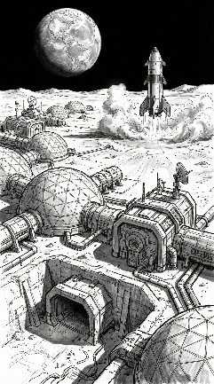***Stellar Ladder : A Blueprint for Lunar Civilization**

Dear Director,

Building a lunar colony with a capacity of 100,000 people and transporting 100 million metric tons of supplies is the most ambitious logistical project in human history. To address this challenge, our team has built an evaluation model based on rigorous data analysis and solemnly puts forward the following strategic recommendations:

* **Firmly implement the "mixed dual-track" transportation system**

Our time-cost balance model shows that there is a fatal flaw in a single mode of transportation. The "pure space elevator" plan is limited by physical capacity, and the "pure rocket" plan will lead to a huge fiscal deficit. Only the hybrid scheme achieved the best balance between cost and duration through Pareto optimization. **We recommend a hybrid strategy with a 150-year baseline that could save $46 trillion compared to a pure rocket option.**

* **Establish a systematic defense against the "quadruple fault"**

Our stochastic reliability simulation framework simulates four core failures that may be faced in the next 100 years: capacity attenuation due to cable swing, high cargo losses due to failed rocket launches, queue delays due to global site heterogeneity, and capacity disruptions due to mechanical elevator downtime. Simulation shows that the hybrid scheme can effectively prevent a single fault from evolving into a systemic collapse through the "risk isolation" mechanism. **We recommend setting aside a 1.5% time buffer (approximately 2-3 years) in the project timeline to absorb the schedule delays caused by the above four random disturbances.**

* **Avoid the "cold start trap" of water supply**

In dynamic planning for the life support system, we found that in the first 3 days of the colony's opening, if the initial inventory is zero, the system will be forced to perform a "saturation rocket rescue" to maintain the bottom line, in the so-called "cold start trap". **We recommend that 2,000 tonnes of water be pre-stocked at the end of the infrastructure construction period, using the remaining capacity.**

* *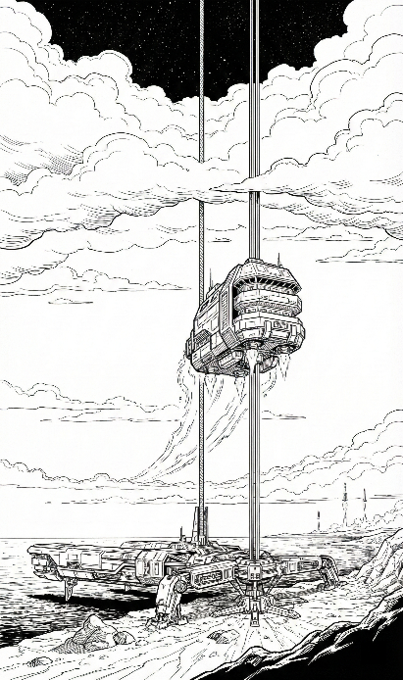***Implement a green construction period of "slow is fast"**

While the financial model supports a 150-year construction period, full life cycle assessments show that excessive rocket launch frequencies will emit large amounts of black carbon into the stratosphere, causing irreversible radiative forcing. When social costs are introduced to internalize environmental externalities, the optimal balance point of the system is displaced. **We recommend adjusting the target duration to 208 years. Although this "green optimal solution" extends the construction period, it can reduce the total cost of society by reducing the proportion of highly polluting rockets.**

**In summary, by implementing a hybrid transportation strategy, building risk defenses, avoiding cold start pitfalls, and adhering to environmental ethics, MCM can not only build a lunar colony, but also set sustainable standards for long-term human prosperity in deep space.**

**Modeling team**

**February 3, 2026**